DSC LAB PROJECT
NAME: Abhishek Vyankatesh Potabatti
Roll no.: SCFU125110
Topic: Students Fee Management System
Github link: https://github.com/sitaramarajuuu/DSC-LAB-PROJECT-
Screenshots of Program Execution:
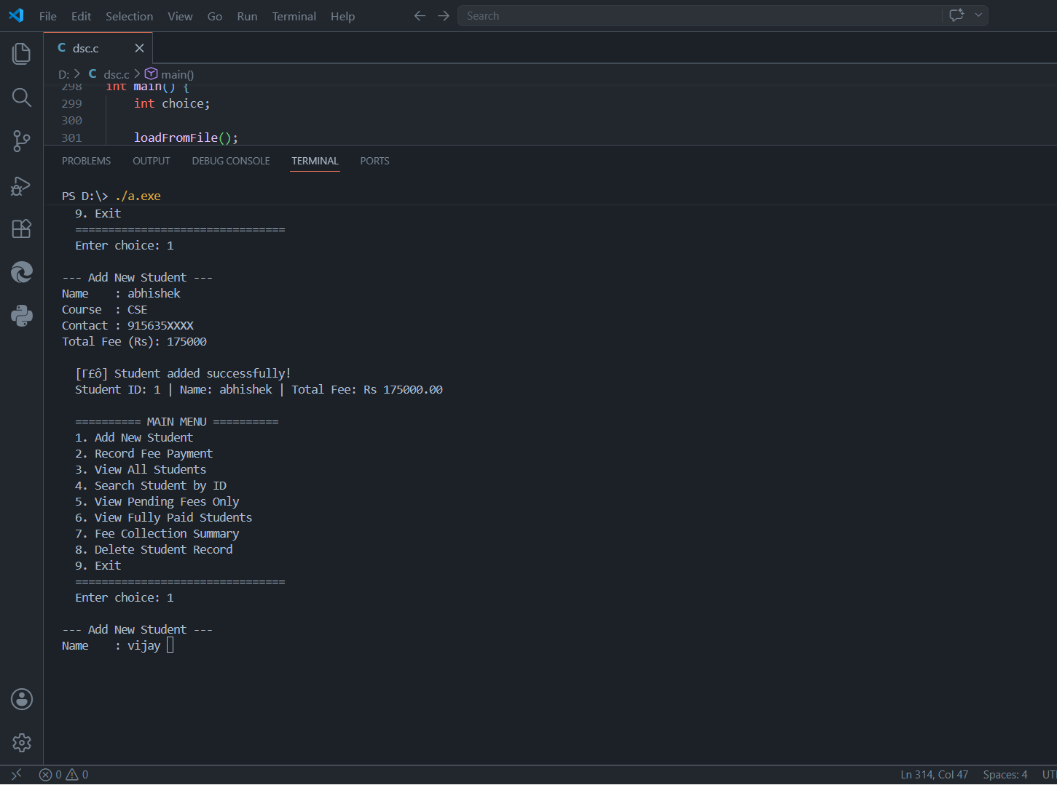

Source Code:
/*
* =============================================
* FEE MANAGEMENT SYSTEM
* Track paid/unpaid fees per student
* =============================================
*/

#include <stdio.h>
#include <string.h>
#include <stdlib.h>

#define MAX_STUDENTS 100
#define FILE_NAME "fees.dat"

/* ---- Student Record Structure ---- */
typedef struct {
int id;
char name[50];
char course[30];
char contact[15];
float totalFee;
float paidAmount;
} Student;

/* ---- Global Data ---- */
Student students[MAX_STUDENTS];
int studentCount = 0;

/* ===================== HELPER FUNCTIONS ===================== */

float getPending(Student s) {
return s.totalFee - s.paidAmount;
}

const char* getStatus(Student s) {
float pending = getPending(s);
if (pending <= 0) return "FULLY PAID";
if (s.paidAmount == 0) return "NOT PAID";
return "PARTIAL";
}

/* Find a student by ID; returns index or -1 if not found */
int findById(int id) {
for (int i = 0; i < studentCount; i++)
if (students[i].id == id) return i;
return -1;
}

/* ===================== FILE OPERATIONS ===================== */

void saveToFile() {
FILE *fp = fopen(FILE_NAME, "wb");
if (!fp) { printf(" [!] Error saving file!\n"); return; }
fwrite(&studentCount, sizeof(int), 1, fp);
fwrite(students, sizeof(Student), studentCount, fp);
fclose(fp);
}

void loadFromFile() {
FILE *fp = fopen(FILE_NAME, "rb");
if (!fp) return;
fread(&studentCount, sizeof(int), 1, fp);
fread(students, sizeof(Student), studentCount, fp);
fclose(fp);
printf(" [✓] %d student record(s) loaded.\n", studentCount);
}

/* ===================== CORE FEATURES ===================== */

/* 1. Add a new student */
void addStudent() {
if (studentCount >= MAX_STUDENTS) {
printf(" [!] Maximum student limit reached!\n"); return;
}

Student s;
s.id = (studentCount == 0) ? 1 : students[studentCount - 1].id + 1;
s.paidAmount = 0;

printf("\n--- Add New Student ---\n");
printf("Name : "); scanf(" %[^\n]", s.name);
printf("Course : "); scanf(" %[^\n]", s.course);
printf("Contact : "); scanf(" %[^\n]", s.contact);
printf("Total Fee (Rs): "); scanf("%f", &s.totalFee);

if (s.totalFee <= 0) { printf(" [!] Fee must be positive!\n"); return; }

students[studentCount++] = s;
saveToFile();

printf("\n [✓] Student added successfully!\n");
printf(" Student ID: %d | Name: %s | Total Fee: Rs %.2f\n", s.id, s.name, s.totalFee);
}

/* 2. Record a fee payment */
void payFee() {
int id;
float amount;

printf("\n--- Record Fee Payment ---\n");
printf("Enter Student ID: ");
scanf("%d", &id);

int idx = findById(id);
if (idx == -1) { printf(" [!] Student ID %d not found!\n", id); return; }

Student *s = &students[idx];
float pending = getPending(*s);

if (pending <= 0) {
printf(" [✓] %s has already paid all fees!\n", s->name); return;
}

printf("\n Student : %s\n", s->name);
printf(" Total : Rs %.2f\n", s->totalFee);
printf(" Paid : Rs %.2f\n", s->paidAmount);
printf(" Pending : Rs %.2f\n", pending);
printf("\nEnter amount to pay (Rs): ");
scanf("%f", &amount);

if (amount <= 0) { printf(" [!] Amount must be positive!\n"); return; }
if (amount > pending) {
printf(" [!] Amount (Rs %.2f) exceeds pending (Rs %.2f)!\n", amount, pending);
return;
}

s->paidAmount += amount;
saveToFile();

printf("\n [✓] Payment of Rs %.2f recorded for %s.\n", amount, s->name);
printf(" Remaining Pending: Rs %.2f\n", getPending(*s));
printf(" Status: %s\n", getStatus(*s));
}

/* 3. View all students */
void viewAll() {
if (studentCount == 0) { printf(" [!] No student records found!\n"); return; }

printf("\n");
printf(" %-5s %-20s %-15s %12s %12s %12s %-12s\n",
"ID", "Name", "Course", "Total(Rs)", "Paid(Rs)", "Pending(Rs)", "Status");
printf(" -----------------------------------------------");
printf("---------------------------------------------------\n");

for (int i = 0; i < studentCount; i++) {
printf(" %-5d %-20s %-15s %12.2f %12.2f %12.2f %-12s\n",
students[i].id,
students[i].name,
students[i].course,
students[i].totalFee,
students[i].paidAmount,
getPending(students[i]),
getStatus(students[i]));
}

printf(" -----------------------------------------------");
printf("---------------------------------------------------\n");
printf(" Total Records: %d\n", studentCount);
}

/* 4. Search a student by ID */
void searchStudent() {
int id;
printf("\nEnter Student ID to search: ");
scanf("%d", &id);

int idx = findById(id);
if (idx == -1) { printf(" [!] Student not found!\n"); return; }

Student s = students[idx];
printf("\n ==============================\n");
printf(" STUDENT DETAILS\n");
printf(" ==============================\n");
printf(" ID : %d\n", s.id);
printf(" Name : %s\n", s.name);
printf(" Course : %s\n", s.course);
printf(" Contact : %s\n", s.contact);
printf(" Total Fee: Rs %.2f\n", s.totalFee);
printf(" Paid : Rs %.2f\n", s.paidAmount);
printf(" Pending : Rs %.2f\n", getPending(s));
printf(" Status : %s\n", getStatus(s));
printf(" ==============================\n");
}

/* 5. Show only students with pending fees */
void viewPendingOnly() {
printf("\n--- Students with Pending Fees ---\n");
int found = 0;

printf(" %-5s %-20s %-15s %12s %-12s\n",
"ID", "Name", "Course", "Pending(Rs)", "Status");
printf(" ----------------------------------------------------------------\n");

for (int i = 0; i < studentCount; i++) {
if (getPending(students[i]) > 0) {
printf(" %-5d %-20s %-15s %12.2f %-12s\n",
students[i].id,
students[i].name,
students[i].course,
getPending(students[i]),
getStatus(students[i]));
found++;
}
}

if (!found) printf(" [✓] No pending fees! All students have paid.\n");
else printf(" Total Students with Pending Fees: %d\n", found);
}

/* 6. Show only students who have fully paid */
void viewPaidOnly() {
printf("\n--- Fully Paid Students ---\n");
int found = 0;

printf(" %-5s %-20s %-15s %12s\n", "ID", "Name", "Course", "Total Paid(Rs)");
printf(" -----------------------------------------------------------\n");

for (int i = 0; i < studentCount; i++) {
if (getPending(students[i]) <= 0) {
printf(" %-5d %-20s %-15s %12.2f\n",
students[i].id,
students[i].name,
students[i].course,
students[i].paidAmount);
found++;
}
}

if (!found) printf(" No fully paid students yet.\n");
else printf(" Total Fully Paid: %d\n", found);
}

/* 7. Overall fee summary / report */
void feeSummary() {
float totalFees = 0;
float totalCollected = 0;
float totalPending = 0;
int fullyPaid = 0;
int partial = 0;
int notPaid = 0;

for (int i = 0; i < studentCount; i++) {
totalFees += students[i].totalFee;
totalCollected += students[i].paidAmount;
totalPending += getPending(students[i]);

if (getPending(students[i]) <= 0) fullyPaid++;
else if (students[i].paidAmount == 0) notPaid++;
else partial++;
}

printf("\n");
printf(" ==========================================\n");
printf(" FEE COLLECTION SUMMARY\n");
printf(" ==========================================\n");
printf(" Total Students : %d\n", studentCount);
printf(" ------------------------------------------\n");
printf(" Total Fee Due : Rs %.2f\n", totalFees);
printf(" Total Collected : Rs %.2f\n", totalCollected);
printf(" Total Pending : Rs %.2f\n", totalPending);
printf(" ------------------------------------------\n");
printf(" Fully Paid : %d student(s)\n", fullyPaid);
printf(" Partial Payment : %d student(s)\n", partial);
printf(" Not Paid at All : %d student(s)\n", notPaid);
printf(" ==========================================\n");
if (totalFees > 0)
printf(" Collection Rate : %.1f%%\n",
(totalCollected / totalFees) * 100);
printf(" ==========================================\n");
}

/* 8. Delete a student record */
void deleteStudent() {
int id;
char confirm;

printf("\nEnter Student ID to delete: ");
scanf("%d", &id);

int idx = findById(id);
if (idx == -1) { printf(" [!] Student not found!\n"); return; }

printf(" Are you sure you want to delete '%s'? (y/n): ", students[idx].name);
scanf(" %c", &confirm);

if (confirm != 'y' && confirm != 'Y') { printf(" Cancelled.\n"); return; }

/* Shift all records after this one */
for (int i = idx; i < studentCount - 1; i++)
students[i] = students[i + 1];

studentCount--;
saveToFile();
printf(" [✓] Student record deleted.\n");
}

/* ===================== MAIN ===================== */
int main() {
int choice;

loadFromFile();

printf("\n");
printf(" *********************************************\n");
printf(" * FEE MANAGEMENT SYSTEM v1.0 *\n");
printf(" * Track Paid / Unpaid Fees per Student *\n");
printf(" *********************************************\n");

while (1) {
printf("\n ========== MAIN MENU ==========\n");
printf(" 1. Add New Student\n");
printf(" 2. Record Fee Payment\n");
printf(" 3. View All Students\n");
printf(" 4. Search Student by ID\n");
printf(" 5. View Pending Fees Only\n");
printf(" 6. View Fully Paid Students\n");
printf(" 7. Fee Collection Summary\n");
printf(" 8. Delete Student Record\n");
printf(" 9. Exit\n");
printf(" ================================\n");
printf(" Enter choice: ");
scanf("%d", &choice);

switch (choice) {
case 1: addStudent(); break;
case 2: payFee(); break;
case 3: viewAll(); break;
case 4: searchStudent(); break;
case 5: viewPendingOnly(); break;
case 6: viewPaidOnly(); break;
case 7: feeSummary(); break;
case 8: deleteStudent(); break;
case 9:
printf("\n Data saved. Goodbye!\n\n");
exit(0);
default:
printf(" [!] Invalid choice! Enter 1-9.\n");
}
}

return 0;
}

